Binalatongan Community College Employee Information System

A Capstone Project Presented to the Faculty of the
Information Technology Department
Binalatongan Community College
San Carlos City, Pangasinan

In Partial Fulfillment of the Requirements
for the Degree of Bachelor of Science
in Information Technology

Submitted by:

Dela Cruz, Juan A.
Doe, John B.
Foo, Bart C.

May 2025
APPROVAL SHEET
This capstone project entitled HOUSE OF BEAUTY ONLINE BOOKING SYSTEM prepared and submitted by HAZELYN LAZAGA SELMO, KRISSA JOYCE PALISOC DEVERA and JESSA FADERO POSADAS in partial fulfillment of the requirements for the degree BACHELOR OF SCIENCE IN INFORMATION TECHNOLOGY, has been examined and is recommended for acceptance and approval.
____________________________
MR. JOSEPH HENRY P. FERNANDEZ
Adviser

PANEL OF EXAMINERS

____________________________
BANNER B. FERRER, MIT
Chairperson

___________________________ ____________________________
HUMPHREY A. DIAZ, MIT JANU V. PERALTA, MIT
Member Member

ACCEPTED and APPROVED in partial fulfillment of the requirements for the degree BACHELOR OF SCIENCE IN INFORMATION TECHNOLOGY on May 17,2022 with a grade of _______.

____________________________ ____________________________
BRIXON J. DE VERA, MIT DR. MACRINA B. CAJALA
Dean, Information Technology Department College President

Abstract

Juan A. Dela Cruz, John B. Doe, Bart C. Foo, “BCC Employee Information System,” Bachelor of Science in Information Technology, College of Information Technology, Binalatongan Community College, San Carlos City, Pangasinan, Philippines, May 2025.

Adviser: Brixon J. De Vera, MIT

Place the abstract here. The abstract must comprehensively cover the scope of the entire research – the problem, the methods, the findings, the conclusions, and the recommendations. Ideally, the abstract must not be more than a page long.

Please check your grammars! You may use an AI Tool or Grammar Checker Application to correct the grammars on this part of your document.

Remember that this page is what the readers check first before browsing the document.This part of the document must inform readers about the content and significance of the research without requiring them to read the entire paper!

Acknowledgement

There should be three single spaces (0 paragraph spacings) between the first line of text and the word “acknowledgement”. This is where you thank everyone who helped you in finishing the research. The acknowledgment must not be more than a page long.

Please check your grammars! You may use an AI Tool or Grammar Checker Application to correct the grammars on this part of your document.

Table of Contents

 |  | Page
Title Page ………………………………………………………………... ……….... |  | i
Approval Form ………………………………………………………………………. |  | ii
Abstract ………………………………………………………………………………… |  | iii
Acknowledgment …………………………………………………………………… |  | iv
Table of Contents ………………………………………………………………….. |  | v
List of Tables ……………..…………………………………………..……………. |  | vii
List of Figures ………………………………………………………..……………... |  | viii
Chapter
1 | INTRODUCTION …………………………………..……......... | 1
 | Background of the Study ……………………………………….. | 1
 | Purpose and Description ……………………………………….. | #
 | Objectives of the Study ……………………………………...….. | #
 | Conceptual Framework (IPO) ……………………………..….. | #
 | Scope and Limitations …………………………………………… | #
 | Definition of Terms …………….……………………………..….. | #
 | Review of Related Literature.……………………………..…… | #
2 | METHODOLOGY AND DESIGN .…………………………. | #
 | Software Development Methodology ……………………… | #
 | Sources of Data …………………………………………………… | #
 | Data Gathering Techniques…………………………………….. | #
 | System Design ..…………………………………………….......... | #
 | System Architecture ……………………………………. | #
 | Dataflow Diagram ………………………………………. | #
 | System Architecture ……………………………………. | #
 | Entity-Relationship Diagram ………………………… | #
 | Implementation Diagram …………………………….. | #
3 | RESULTS AND DISCUSSION
 | System Process Flowchart.………………………. | #
 | System Features and User Interfaces ………………………. | #
 | System Testing and Evaluation …………………....…………. | #
 | Implementation Results .…………………………………......... | #
 | Analysis of Results ………...………………………………......... | #
 | Discussion of Findings ………………..……………………….... | #
4 | RECOMMENDATIONS.…………………………………………. | #
Appendices ………………………….……………………….…………………….. |  | #
A | Endorsement Letter ………………………………………………… | #
B | System Source Codes ………………………..…….…………….. | #
C | Database Schema (Actual Database Structure) ….……… | #
D | Survey/Evaluation Forms Used During Testing ………….. | #
E | Collected Sample Documents for Document Analysis/Data Gathering…..………………………………………. | #
Curriculum Vitae …………………………………………………………………. |  | #
List of Tables

Table | Title | Page
4.1 | Table Name | #
These are only NOTES:

Please remember that all tables in the paper must be numbered! For Example:

Table 4.1 : Name of the Table

In the table numbering format given above, the first number corresponds to the chapter number and the second number is the table count within the specific chapter. So, the numbering above means that it is 1st table within chapter 4.

Once all tables in the document are numbered, please indicate the table number, name and page number here!

List of Figures

Figure | Title | Page
3.# | Input Process Output | #
3.# | Existing Process Flowchart | #
3.# | Entity Relationship Diagram | #
3.# | Data Flow Diagram | #
3.# | and so on….. | #

These are only NOTES:

Figures are charts, graphs, diagrams, photographs, illustrations, or any visual element that aids in understanding the research.

Please remember that all figures in the paper must be numbered! For Example:

Figure 3.2 : Inventory Management Form Page
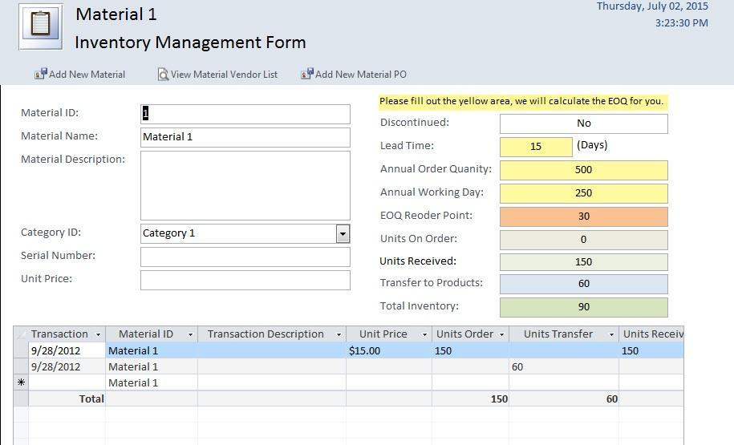

In the figure numbering format given above, the first number corresponds to the chapter number and the second number is the figure count within the specific chapter. So, the numbering above means that the figure is the 2nd figure within chapter 3.

Once all figures in the document are numbered, please indicate the figure number, name/title and page number here!

